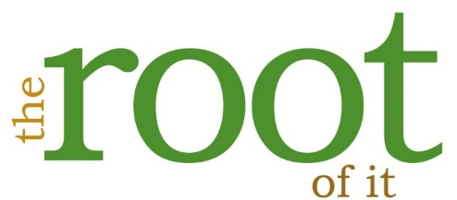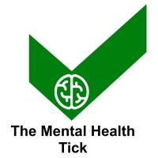
The Mental Health and Wellbeing Awards 2024
Name: |  | Organisation:
Email: |  | Phone:
Address:
Type of organisation:

About your entry
- You are required to evidence how your organisation has gone above and beyond the expectations for your setting in your chosen category. Entries are scored on three different factors and entries must answer each of the three questions on this form:
- Evidence of going above and beyond the expectations for their type of work
- Evidence of innovation
- Evidence of sustained impact over at least 2 consecutive years
- Please evidence why you should win this category (please complete a separate entry for each category you wish to enter – photographs are allowed) and return the entry to awards@rootofit.com before 30th May 2024.
- Appendices are allowed as evidence of what you put in your entry, but do not constitute part of your main entry (e.g. you may append data, research or articles that you refer to).
- Organisations are allowed to only submit a maximum of three entries across all of the categories.
- Entries for Inspirational Story and Contribution to the Sector Categories must not be self-nominated and should include views from different people/organisations.
- Shortlisted entries for the Contribution to the Sector Category will be notified and invited to the presentation ceremony. Nominees not shortlisted will not be contacted and feedback will be provided to the entrant. The list of shortlisted entries will be advertised.
- Winning entries are displayed on our website at www.mentalhealthandwellbeingawards.com, please indicate any sections you would not want publishing.
- Winners may enter again, but cannot enter in the same category for 2 years. In the event of a re-entry to the same category, then it is expected that the entry will refer to the progress since the first award. Non-winners are able to re-enter the same category (or others), however it is expected the entry will have been updated from the previous entry.
- Feedback will be given to non-winning entrants by email after the Awards Ceremony.
Category (please select one):
☐ 1 - Innovative mental health intervention
☐ 2 - Innovative proactive wellbeing activity
☐ 3 - Long-term impact (open to reactive or proactive interventions)
☐ 4 - The lifestyle award (evidence of lifestyle change in a population)
☐ 5 - Support during the pandemic
☐ 6 - Workplace Wellbeing
7 - There is a separate form for the outstanding contribution to the mental health and wellbeing sector category available on the website.
8 - There is a separate form for the inspirational story category available on the website.
9 - There is a separate form for nominate a professional available on the website.

Provide a short summary (max 150 words) of the organisation and their contribution for use if you are shortlisted.

Introduce your organisation or context of the entry in the space below

Please confirm the following for the nominated service (enter n/a if not appropriate):
Is it regulated by appropriate bodies (e.g. CQC or OfSTED)?
Is it a registered charity or a registered social enterprise?
Does it have a safeguarding policy/risk assessment/clinical governance policies and procedures (including the protection of staff’s wellbeing)?
It is GDPR compliant?
Is there any action being taken by a regulator against you?

Describe in the space below how do you/they go above and beyond the expectations.

Categories 1 and 2: Describe how the work is innovative (e.g. ground-breaking or different from similar services).
Category 3: Describe how the work has had an impact over time.
Category 4: Describe how the work has had an impact on a large population.
Category 5: Describe how the work has made an impact to people during the pandemic.

How is the impact sustained over at least two consecutive years? This might include data, testimonials, feedback or other types of evidence. (for the pandemic category, please describe how you have found innovative ways of providing or growing services)

Please return the entry to awards@rootofit.com before 30th May 2024.

